

Lesson 1

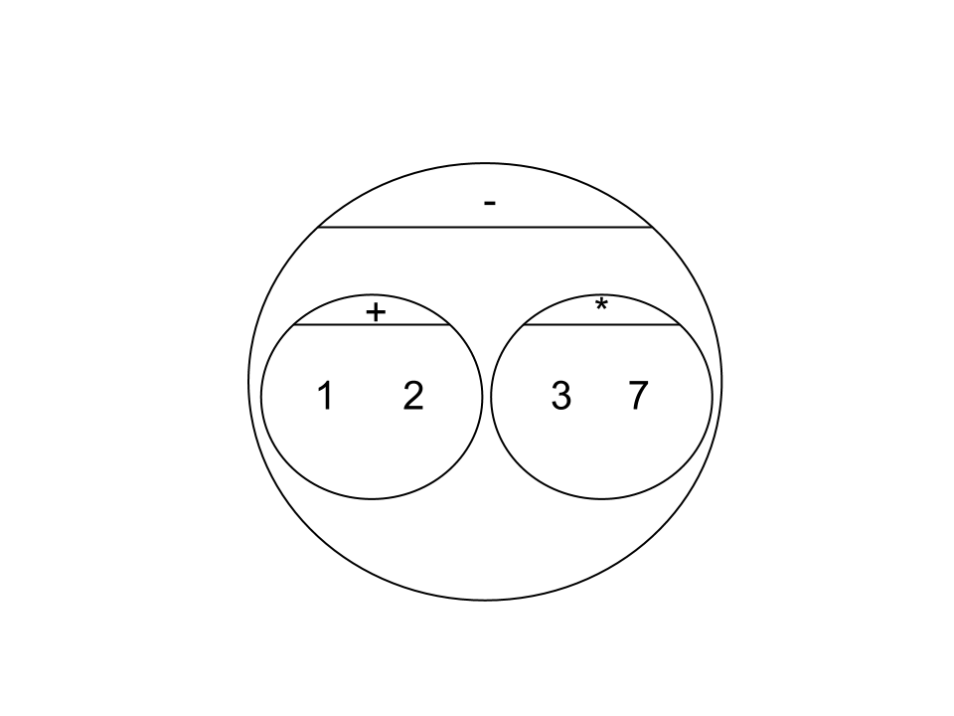
Circles Competition Time: 5 minutes
 | Math | Circle of Evaluation | Scheme Code
Round 1 | 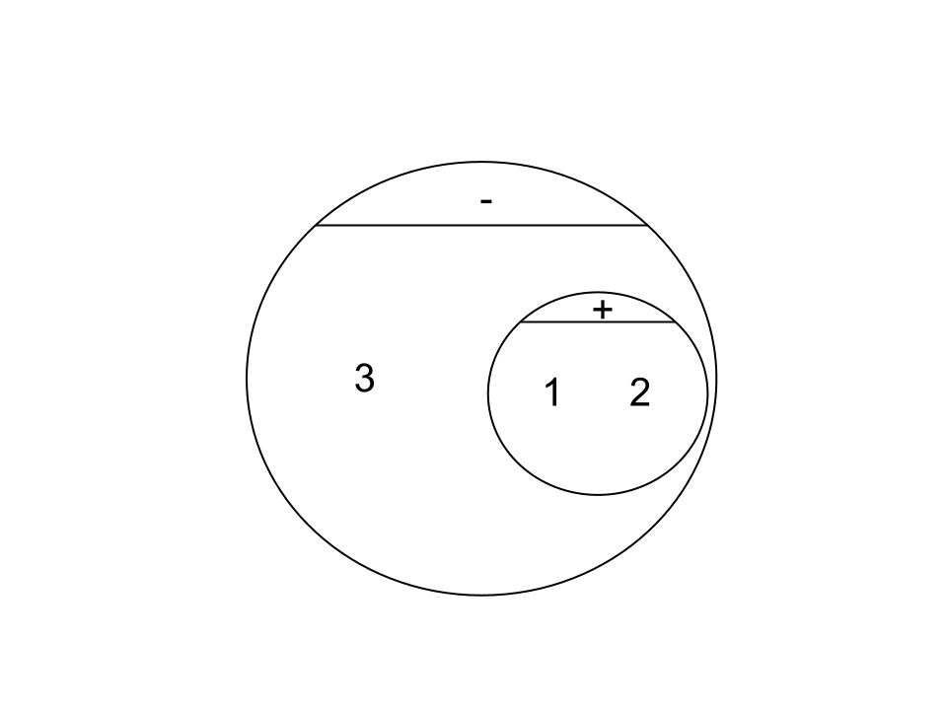  (1 + 2) - (3 * 7) |  | (- (+ 1 2) (* 3 7))
Round 2 | 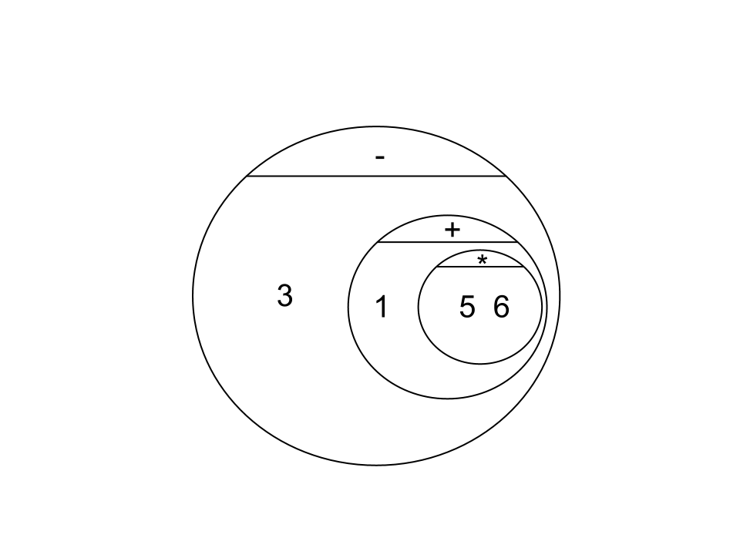  3 - (1 + 2) |  | (- 3 (+ 1 2))
Round 3 | 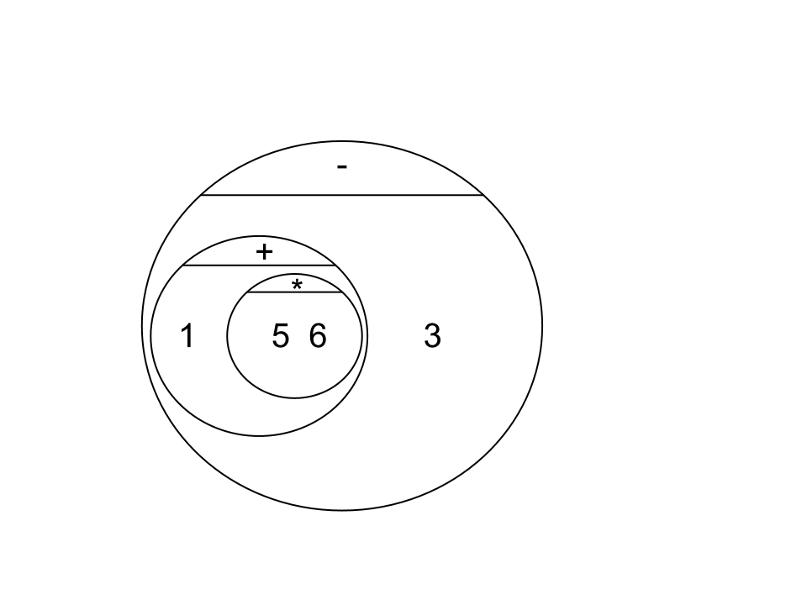  3 - (1 + (5 * 6)) |  | (- 3 (+ 1 (* 5 6)))
Round 4 | (1 + (5 * 6)) - 3 |  | (- (+ 1 (* 5 6)) 3)


Fast Functions!
Fill out the contract for each function, then try to write two examples and the definition by yourself.
; _double____________:__Number________ -> _Number________
name domain range
(EXAMPLE (_double_ __5__) _( * 2 5 )_____________)
(EXAMPLE (_double_ __7__) _( * 2 7 )_____________)
(define (__double_ _n____) _( * 2 n )________________)
; _triple_________ : __#____________ -> __#______________
name domain range
(EXAMPLE (triple_ 7____) __(* 3 7)______________)
(EXAMPLE (triple_ 9____) __(* 3 9)______________)
(define (_triple_ _n__) ___(* 3 n)________________)
; __plus1__________:__#______________ -> ___#_____________
(EXAMPLE (plus1__ _4_____) _(+ 1 4 ) ___________________)
(EXAMPLE ( plus1 __13______) (+ 1 13 ) ____________________)
(define (_plus1_ __n_____) _(+ 1 n) ___________________)
; __mystery_______:___#______________ -> ___#_____________
(EXAMPLE (_mystery_ _5_) _(- 7 4 )_______________)
(EXAMPLE (_mystery_ _8_) _(- 7 8 )_______________)
(define (_mystery_ _x_) _(- 7 x)_______________)

Lesson 2

Design Recipe: SAMPLE

State the problem:

Make a circle (spot) of size 100, with the provided color

Contract+Purpose Statement
Every contract has three parts:

; ___spot100____ : String -> Image
name Domain Range

; Makes a size 100 circle in a color What does the function do?

Give Examples

On the computer, write an example of your function in action, using EXAMPLE.

(EXAMPLE ( spot100 “green” )(circle 100 “solid” “green” ))
the user types… ...which should become
color

(EXAMPLE ( spot100 “blue” )(circle 100 “solid” “blue” ))
the user types… ...which should become

Function
Circle the changes in the EXAMPLEs, and name the variables.
Write the code, copying everything that isn't circled, and using names where you find variables!

(define (spot100 color ) (circle 100 “solid” color ))
function name variable names ...and the computer does this

Design Recipe: double-radius

State the problem:
Write a function, double-radius, which takes in a radius and color, and makes an outline circle of the same color, but double the size

Contract+Purpose Statement
Every contract has three parts:

; __double-radius________ : __Number String______ -> __Image_________
name Domain Range

; Doubles the radius, and draws a circle of that new size and color
What does the function do?

Give Examples
On the computer, write an example of your function in action, using EXAMPLE.
EXAMPLE (double-radius 6 “blue”) (circle (* 2 6) “outline” “blue”) )
the user types… ...which should become

(EXAMPLE (double-radius 10 “red”) (circle (* 2 10) “outline” “red”) )
the user types… ...which should become

Function
Circle the changes in the EXAMPLEs, and name the variables.
Write the code, copying everything that isn't circled, and using names where you find variables!

(define (double-radius radius color) (circle (* 2 radius) “outline” color) )

Design Recipe: double-width

State the problem:
Write a function, double-width, which takes in a height and a color, and makes a solid rectangle, where the width is twice the height

Contract+Purpose Statement
Every contract has three parts:

; __double-width__ : __Number String___________ -> __Image__
name Domain Range

; draws a rectangle where the width is twice the height, of the given color
What does the function do?

Give Examples
On the computer, write an example of your function in action, using EXAMPLE.

(EXAMPLE (double-width 3 “green”) (rectangle 3 (* 2 3) “solid” “green”))
the user types… ...which should become

(EXAMPLE (double-width 7 “yellow”) (rectangle 7 (* 2 7) “solid” “yellow”))
the user types… ...which should become

Function
Circle the changes in the EXAMPLEs, and name the variables.
Write the code, copying everything that isn't circled, and using names where you find variables!

(define (double-width h color) (rectangle h (* 2 h) “solid” color))

Design Recipe: paint-job

State the problem:
Write a function called paint-job that takes an auto and changes its color

Contract+Purpose Statement
; _paint-job_______ : __auto string____________________ -> __auto__________
name Domain Range
; takes in an auto and a color, and returns an auto with that color
What does the function do?

Give Examples
(EXAMPLE (_paint-job____ ___car1 “green”___________________)
(make-auto (auto-model car1)_______________________
____________(auto-hp car1)_______________________
____________(auto-rims car1)_______________________
____________”green”_______________________
____________(auto-value car1)___________)____________)
(EXAMPLE (_paint-job____ ___car2 “black”___________________)
(make-auto (auto-model car2)_______________________
____________(auto-hp car2)_______________________
____________(auto-rims car2)_______________________
____________”black”_______________________
____________(auto-value car2)___________)____________)

Function
(define (_paint-job____ ___auto color___________________)
(make-auto (auto-model auto)_______________________
____________(auto-hp auto)_______________________
____________(auto-rims auto)_______________________
____________color_______________________
____________(auto-value auto)___________)____________)

Design Recipe: turbo-charge

State the problem:
Write a function called turbo-charge that takes an auto and adds 20 hp

Contract+Purpose Statement
; _turbo-charge______ : _auto___________________________ -> __auto________
name Domain Range
; takes in an auto and returns the same auto, with twenty more hp_____________
What does the function do?

Give Examples
(EXAMPLE (_turbo-charge___ __car1_____________________________)
(make-auto _(auto-model car1)___________________________
_(+ 20 (auto-hp car1))___________________________
_(auto-rims car1)___________________________
_(auto-color car1)___________________________
_(auto-value car1) )___________________________)
(EXAMPLE (_turbo-charge___ __car2_____________________________)
(make-auto _(auto-model car2)___________________________
_(+ 20 (auto-hp car2))___________________________
_(auto-rims car2)___________________________
_(auto-color car2)___________________________
_(auto-value car2) )___________________________)

Function
(define (_turbo-charge___ __auto_____________________________)
(make-auto _(auto-model auto)___________________________
_(+ 20 (auto-hp auto))___________________________
_(auto-rims auto)___________________________
_(auto-color auto)___________________________
_(auto-value auto) )___________________________)

Lesson 3

Design Recipe: pimp

State the problem:
+100 hp, red, +10000 value, 30” rims

Contract+Purpose Statement
; ___pimp_________ : __auto________________________________ -> __auto____________
name Domain Range
; takes in an auto and makes it red, 30” rims, +100 hp and +10000 value
What does the function do?

Give Examples
(EXAMPLE (__pimp______ __car1________________________________)
_(make-auto (auto-model car1)________________________
____________(+ 100 (auto-hp car1))____________________
____________30_____________________________________
____________”red”___________________________________
____________(+ 10000 (auto-value car1)))_______________)
(EXAMPLE (__pimp______ __car2________________________________)
_(make-auto (auto-model car2)________________________
____________(+ 100 (auto-hp car2))____________________
____________30_____________________________________
____________”red”___________________________________
____________(+ 10000 (auto-value car2)))_______________)

Function
(define (__pimp______ __auto________________________________)
_(make-auto (auto-model auto)________________________
____________(+ 100 (auto-hp auto))____________________
____________30_____________________________________
____________”red”___________________________________
____________(+ 10000 (auto-value auto)))_______________)

define-struct

Autos:

; an auto is a (make-auto string number number string number)

(define-struct auto (model_____________
hp_______________
rims______________
color______________
value______________))

; a party is a _string string number___________________

(define-struct party (location____________
theme______________
guests______________))

Design Recipe: RSVP

State the problem:
Add 1 to the # of guests

Contract+Purpose Statement

; __RSVP___________ : __party_______________________________ -> _party_____________
name Domain Range
; __Add 1 to the number of guests in the party______________________________________
What does the function do?

Give Examples
(EXAMPLE (__RSVP_____ ___Halloween__________________________)
__(make-party (party-location Halloween)_________________
_____________(party-theme Halloween)___________________
_____________(+ 1 (party-guests Halloween)))____________________)
(EXAMPLE (__RSVP_____ ___Summer__________________________)
__(make-party (party-location Summer)_________________
_____________(party-theme Summer)___________________
_____________(+ 1 (party-guests Summer)))____________________)

Function

(define (__RSVP_____ ___party__________________________)
__(make-party (party-location party)_________________
_____________(party-theme party)___________________
_____________(+ 1 (party-guests party)))____________________)

Design Recipe: relocate

State the problem:

Contract+Purpose Statement

; __________________ : _________________________________________ -> ______________
name Domain Range
; _______________________________________________________________________________
What does the function do?

Give Examples
On the computer, write an example of your function in action, using EXAMPLE.

(EXAMPLE (______________ __________________________________)
___________________________________________
___________________________________________
___________________________________________)
(EXAMPLE (______________ __________________________________)
___________________________________________
___________________________________________
___________________________________________)

Function

(define (______________ _________________________________)
___________________________________________
___________________________________________
___________________________________________)

Dissecting a Demo: Ninja World
What changes?
_______________________________________________
_______________________________________________
_______________________________________________
_______________________________________________

Ninja World:
; a world is a _________________________________________

(define-struct world (_________________))

My constructor function is:
1) (How do you make a world?)__________________________
What is its contract? _________________________________
My accessor function is:
2) (How do you get the dogX out of the world?)
___________________________________________
What is its contract? _________________________________

Design Recipe: update-world (Ninja World)

State the problem:

Contract+Purpose Statement

; ________________ : _______________ -> ______________
name Domain Range
;__________________________________________________________
What does the function do?

Give Examples
On the computer, write an example of your function in action, using EXAMPLE.

(EXAMPLE (____________ ______________________)
___________________________________________)
(EXAMPLE (_________ _________________________)
___________________________________________)

Function

(define (___________ ___________________________)

___________________________________________)

Lesson 4

Review: define-struct
Last week we talked about a function that created new structs. For the structs below, what function would you use for each of the following?

; an auto is a String __________ Number ________ Number
(define-struct auto (model hp rims color value))
Make an auto? _______________________________
Get the model out of an auto? ___________________
Get the hp out of an auto? ______________________

; a party is a _______ String Number
(define-struct team (location theme guests))
Make a team? _________________________________
Get the city out of the team? _____________________
Get the sport out of the team? ___________________
Get the rank out of the team? ______________________
; a world is a Number
(define-struct world (dogX))
What function would you use to:
Make a world? ___________________________________
Get the dogX out of the world? ______________________

Game Design
“Start Simple, Get Complex”

Draw a rough sketch of your game in action

What images will you need for your game?
Background

List everything that has changed, and the datatype you will use to represent it
Changed (position? score? color? costume?) | Datatype (number? string? image? boolean?)

; a world is a _________________________________________
(define-struct world (_________________
_________________
_________________
_________________
_________________))

My constructor function is…

; make-world : _____________________________________ → World

My accessor functions are…
;______________________________________________
;______________________________________________
;______________________________________________
;______________________________________________
;______________________________________________

Lesson 5

(0, 480) START (640,480)
(0, 0) (640, 0)
At the start of my game, this is where everything is:
Object (top to bottom of stack) | Position (x, y)
Background

(define START(make-world _________________
_________________
_________________
_________________
_________________))
(0, 480) NEXT (640,480)
(0, 0) (640, 0)
A split second later, this is where everything is:
Object (top to bottom of stack) | Position (x, y)
Background

(define NEXT (make-world _________________
_________________
_________________
_________________
_________________))

draw-world

Contract

; __________________ : _________________________________________ -> ______________

Using put-image

(define (____________ _______________________________)
(put-image ________________
________________
(put-image ________________
________________
(put-image ________________
________________
(put-image ______________
_______________
BACKGROUND _______

Design Recipe: update-world

State the problem (What changes?):

Contract+Purpose Statement

; __________________ : _________________________________________ -> ______________
name Domain Range
; _______________________________________________________________________________
What does the function do?

Give Examples
On the computer, write an example of your function in action, using EXAMPLE.

(EXAMPLE (______________ __________________________________)
___________________________________________
___________________________________________
___________________________________________
___________________________________________
___________________________________________)
(EXAMPLE (______________ __________________________________)
___________________________________________
___________________________________________
___________________________________________
___________________________________________
___________________________________________)

Function

(define (______________ _________________________________)
___________________________________________
___________________________________________
___________________________________________
___________________________________________
___________________________________________)

Lesson 6
When the user presses… | this part... | Changes by…

Design Recipe

State the Problem
For each keypress in the Ninja World game, show how (keypress START <key>) should change your world.

Contract+Purpose Statement
; : ->
name Domain Ranges

Give Examples

(EXAMPLE (keypress START __________________________________)

(make-world _____________________________________

_____________________________________

_____________________________________

_____________________________________

_____________________________________))

(EXAMPLE (keypress START __________________________________)

(make-world _____________________________________

_____________________________________

_____________________________________

_____________________________________

_____________________________________))

(define (_______________ __________________________________)
(cond
[(_________________________________________________)

_____________________________________________________

_____________________________________

_____________________________________

_____________________________________

_____________________________________]

[(_________________________________________________)

_____________________________________________________

_____________________________________

_____________________________________

_____________________________________

_____________________________________]))

Design Recipe

State the Problem
For each keypress in your game, show how (keypress START <key>) should change your world.

Contract+Purpose Statement
; : ->
name Domain Ranges

Give Examples

(EXAMPLE (keypress START __________________________________)

(make-world _____________________________________

_____________________________________

_____________________________________

_____________________________________

_____________________________________))

(EXAMPLE (keypress START __________________________________)

(make-world _____________________________________

_____________________________________

_____________________________________

_____________________________________

_____________________________________))

(EXAMPLE (keypress START __________________________________)

(make-world _____________________________________

_____________________________________

_____________________________________

_____________________________________

_____________________________________))
___________________________________________________________________________________________________
(define (________________ __________________________________)
(cond
[(_________________________________________________)

_____________________________________________________

_____________________________________

_____________________________________

_____________________________________

_____________________________________]

[(_________________________________________________)

_____________________________________________________

_____________________________________

_____________________________________

_____________________________________

_____________________________________]

[(_________________________________________________)

_____________________________________________________

_____________________________________

_____________________________________

_____________________________________

_____________________________________]))

Lesson 7

Extended update-world:
; __off-right?___:_________________ -> ________________
name domain range
(EXAMPLE (__________ ______) _______________________)
(EXAMPLE (__________ ______) _______________________)
(define (__________ ______) _______________________)
; _off-left?___:_________________ -> ________________
(EXAMPLE (__________ ______) _______________________)
(EXAMPLE (__________ ______) _______________________)
(define (__________ ______) _______________________)
; ________________:_________________ -> ________________
(EXAMPLE (__________ ______) _______________________)
(EXAMPLE (__________ ______) _______________________)
(define (__________ ______) _______________________)
; ________________:_________________ -> ________________
(EXAMPLE (__________ ______) _______________________)
(EXAMPLE (__________ ______) _______________________)
(define (__________ ______) _______________________)

TEST | RESULT
(make-world ___________________________________
___________________________________
___________________________________
___________________________________
___________________________________)
(make-world ___________________________________
___________________________________
___________________________________
___________________________________
___________________________________)
(make-world ___________________________________
___________________________________
___________________________________
___________________________________
___________________________________)
(make-world ___________________________________
___________________________________
___________________________________
___________________________________
___________________________________)

Lesson 8

Design Recipe: line-length
Write a function called line-length, which takes in two numbers and returns the difference between them. It should always subtract the smaller number from the bigger one.

Contract+Purpose Statement
Every contract has three parts:

; __________________ : _________________________________________ -> ______________
name Domain Range

Give Examples

(EXAMPLE ( _______________ ______) ______________________ )

(EXAMPLE ( _______________ ________________) ______________________)

Function Header
Write the Function Header, giving variable names to all your input values that change.

(define (____________ ___________________)
function name variable names

________________________________

))

Distance:

The Player is at (4, 2) and the Target is at (0, 5).
Distance takes in the player-x, player-y, character-x and character-y.

Use the formula below to fill in the EXAMPLE:
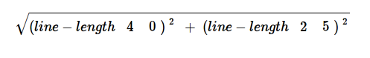

Convert it into a Circle of Evaluation. (We've already gotten you started!)

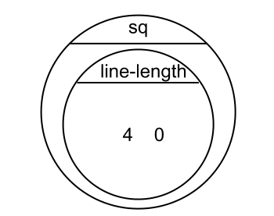

Convert it into Racket code:
(EXAMPLE (_______________ ______________________)

(________________________________________________

__________________________________________________)

Design Recipe: distance
Write a function distance,which takes FOUR inputs:
- px: The x-coordinate of the player
- py: The y-coordinate of the player
- cx: The x-coordinate of another game character
- cy: The y-coordinate of another game character

It should return the distance between the two, using the Distance formula:
Distance = ((line-length px cx)² + (line-length py cy)² )

Contract+Purpose Statement

; __________________ : _________________________________________ -> ______________
name Domain Range

; _______________________________________________________________________________
What does the function do?

Give Examples

(EXAMPLE (___________________________________________)

____________________________________________________)

(EXAMPLE (___________________________________________)

____________________________________________________)

Function Header

(define (____________ ___________________)
function name variable names

___________________________________________________)

Design Recipe: collide?

Write a function collide?,which takes FOUR inputs:
- px: The x-coordinate of the player
- py: The y-coordinate of the player
- cx: The x-coordinate of another game character
- cy: The y-coordinate of another game character
It should return true if the coordinates of the player are within 75 pixels of the
coordinates of the other character. Otherwise, false.

Contract+Purpose Statement

; __________________ : _________________________________________ -> ______________
name Domain Range

; _______________________________________________________________________________
What does the function do?

Give Examples

(EXAMPLE (___________________________________________)

_________________________________________________)

(EXAMPLE (___________________________________________)

_________________________________________________)

Function Header

(define (____________ ___________________)

________________________________________________)

TEST | RESULT
(make-world ___________________________________
___________________________________
___________________________________
___________________________________
___________________________________)
(make-world ___________________________________
___________________________________
___________________________________
___________________________________
___________________________________)
(make-world ___________________________________
___________________________________
___________________________________
___________________________________
___________________________________)
(make-world ___________________________________
___________________________________
___________________________________
___________________________________
___________________________________)

Supplemental

Design Recipe

State the problem:

Contract+Purpose Statement
Every contract has three parts:

; __________________ : _________________________________________ -> ______________
name Domain Range

; _______________________________________________________________________________
What does the function do?

Give Examples
On the computer, write an example of your function in action, using EXAMPLE.

(EXAMPLE (_______ _____________) _________________________________)
the user types… ...which should become

(EXAMPLE (_______ _____________) _________________________________)
the user types… ...which should become

Function
Circle the changes in the EXAMPLEs, and name the variables.
Write the code, copying everything that isn't circled, and using names where you find variables!

(define (_______ _____________) _________________________________)

Design Recipe

State the problem:

Contract+Purpose Statement
Every contract has three parts:

; __________________ : _________________________________________ -> ______________
name Domain Range

; _______________________________________________________________________________
What does the function do?

Give Examples
On the computer, write an example of your function in action, using EXAMPLE.

(EXAMPLE (_______ _____________) _________________________________)
the user types… ...which should become

(EXAMPLE (_______ _____________) _________________________________)
the user types… ...which should become

Function
Circle the changes in the EXAMPLEs, and name the variables.
Write the code, copying everything that isn't circled, and using names where you find variables!

(define (_______ _____________) _________________________________)

TEST | RESULT
(make-world ___________________________________
___________________________________
___________________________________
___________________________________
___________________________________)
(make-world ___________________________________
___________________________________
___________________________________
___________________________________
___________________________________)
(make-world ___________________________________
___________________________________
___________________________________
___________________________________
___________________________________)
(make-world ___________________________________
___________________________________
___________________________________
___________________________________
___________________________________)

